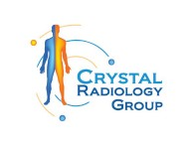6 Important Types of X-rays, Everyone Must Know at Crystal Radiology. (02) 8315 8292

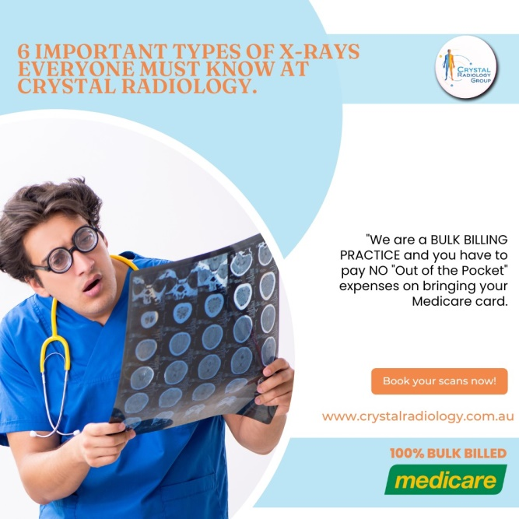X-rays, also known as radiographs, are non-invasive medical imaging techniques that allow healthcare providers to see inside the body without surgery. By using a safe level of radiation, X-rays produce images of bones, tissues, and organs, aiding in the diagnosis and treatment of injuries, diseases, and other health conditions. The versatility of [X-rays](https://crystalradiology.com.au/x-ray/) makes them an essential tool in various medical fields.

At Crystal Radiology, we use state-of-the-art X-ray technology to help diagnose a wide range of conditions. Here, we will explore six important types of X-rays, each serving a unique purpose in modern healthcare.

**1. Bone X-ray**

**Purpose and Use:**

Bone X-rays are commonly used to evaluate injuries and conditions related to the bones. These X-rays provide clear images of the bones in different parts of the body, such as the arm, shoulder, spine, leg, and foot. They are essential for diagnosing:

**• Fractures:** Bone X-rays are typically the first test used to identify fractures and assess their severity.

**• Dislocated Joints:** They help determine the extent of joint [dislocation](https://crystalradiology.com.au/x-ray/) and guide doctors in repositioning the joint.

**• Degenerative Bone Diseases:** Conditions such as arthritis and osteoporosis can be diagnosed using bone X-rays, which reveal bone degradation over time.

**• Bone Infections and Tumors:** These X-rays can identify signs of infection or abnormal growths within the bones.

Bone X-rays are also helpful in planning orthopedic surgeries and locating foreign objects embedded near or around the bones.

**2. Dental X-ray**

**Purpose and Use:**

Dental X-rays provide detailed internal images of the teeth, gums, and jaw. They are essential for diagnosing issues that may not be visible during a regular dental check-up, including:

**• Cavities:** Dental X-rays help detect hidden cavities between teeth or under fillings.

**• Bone Loss and Decay:** They reveal signs of bone loss in the jaw and any decay beneath existing fillings.

**• Infections and Abscesses:** X-rays can identify [underlying](https://crystalradiology.com.au/x-ray/) infections and abscesses that might be causing pain or swelling.

**• Impacted Teeth:** These images help dentists assess the position of unerupted teeth and decide on orthodontic treatment.

Dental X-rays are crucial for planning procedures such as root canals, dental implants, and post-surgery recovery.

**3. Abdominal X-ray**

**Purpose and Use:**

Abdominal X-rays are used to capture images of internal organs like the stomach, liver, kidneys, and bladder. They are commonly used to diagnose:

**• Bladder and Kidney Stones:** Abdominal X-rays can detect the size and location of stones in the urinary system.

**• Abdominal Pain:** These X-rays help investigate causes of abdominal pain, such as bowel obstructions or intestinal perforations.

**• Swallowed Objects:** When foreign objects are ingested, [abdominal X-rays](https://crystalradiology.com.au/x-ray/) can pinpoint their location within the digestive tract.

Specialized abdominal X-rays, such as those with contrast dyes (like barium enemas), provide more detailed images for gastrointestinal diagnoses.

**4. Chest X-ray**

**Purpose and Use:**

Chest X-rays capture images of the lungs, heart, and chest bones (such as ribs and spine). They are one of the most frequently used imaging tests for diagnosing:

**• Lung Conditions:** Chest X-rays help diagnose conditions like pneumonia, tuberculosis, lung cancer, and chronic obstructive pulmonary disease [(COPD).](https://crystalradiology.com.au/x-ray/)

**• Heart Issues:** They assess the size and shape of the heart to identify conditions such as heart failure or fluid buildup.

**• Rib Fractures:** Chest X-rays detect fractures in the ribs, which may cause chest pain.

They are typically used to evaluate respiratory symptoms like a persistent cough, chest pain, or difficulty breathing.

**5. Mammogram**

**Purpose and Use:**

Mammograms are specialized X-rays used to examine breast tissue for early detection of breast cancer. They come in two forms:

**• Screening Mammogram:** Used for preventive screening, this test detects early signs of breast cancer before any symptoms develop.

**• Diagnostic Mammogram:** Performed when there are signs of [breast abnormalities](https://crystalradiology.com.au/x-ray/), such as lumps, pain, or nipple discharge, to investigate further.

Mammograms play a key role in identifying breast cancer at its earliest stages, improving treatment outcomes.

**6. Angiogram**

Purpose and Use:

An angiogram is an X-ray technique used to visualize blood vessels. It helps doctors evaluate blood flow and detect blockages or irregularities. Common uses include:

**• Blocked Blood Vessels:** Angiograms identify blockages in arteries, which may require interventions like angioplasty.

**• Vascular Injuries:** They detect issues like aneurysms, which are bulging blood vessels that pose serious risks.

**• Heart Conditions:** Coronary [angiograms](https://crystalradiology.com.au/x-ray/) examine the heart’s blood vessels to diagnose coronary artery disease.

This test helps guide treatment for cardiovascular conditions and ensures proper blood flow throughout the body.

**How Do X-rays Work?**

X-rays work by sending a small dose of radiation through the body. Different tissues and structures absorb the radiation at different levels, which creates a contrast in the resulting image.

* Bones, which are dense and contain calcium, absorb more radiation and appear white on the X-ray.
* Soft tissues, such as organs, absorb less radiation and appear as varying shades of grey.
* Air-filled areas, like the lungs, absorb the least radiation and appear dark on the X-ray.
* This contrast allows doctors to assess the internal structure of the body accurately and make informed [diagnostic decisions](https://crystalradiology.com.au/x-ray/).

**Conclusion**

X-rays are a powerful diagnostic tool that is critical in modern healthcare. At Crystal Radiology, we offer a comprehensive range of X-ray services, from routine bone and dental X-rays to specialized tests like mammograms and angiograms.Understanding the different types of X-rays and their applications can help you make informed decisions about your health, ensuring you receive the most appropriate care for your condition.

**Why Choose Crystal Radiology?**

We are local and a Privately-owned medical Clinics that offers the highest quality medical and Imaging Services in the [Crystal region](https://crystalradiology.com.au/appointment/). We are the leaders in Bulk Billing with the real benefit of no ‘Out of Pocket’ expenses for you.

**Your Next Step**

Please ensure that you have your Medicare card and referral with you and pop into our location for your consultation. If you have any questions at all, please feel free to contact us on [(02) 8315 8292](https://crystalradiology.com.au/appointment/)  as we are here to help.